
Press Kit

Company Background

Nippura is known for its core business of creating the world’s largest acrylic panels, tunnels, cylinders and spheres for the professional aquarium industry. Nippura was the first company ever in 1968 to produce a large scale aquarium from acrylic (PMMA). Nippura has been the catalyst for the modernization of theme park aquariums. While Nippura Aquarium products can be found all over the world you may find yourself staring through them at some of the more local notable aquariums like the Monterey Bay Aquarium, Atlantis Paradise Island, Baltimore Aquarium, New York Aquarium, Ripley’s Aquarium Gatlinburg, & the new Georgia Aquarium just to mention a few… The largest size Aquarium Window Aqua-wall® created to date by Nippura measures more 74’ x 27’ x 2’ thick (297,000lbs) and listed in the 2004 Guinness Book of Records. Nippura’s technology for consistently producing hi-tolerance cell cast acrylic in large sizes with exacting optical properties has been leveraged for developing Blue Ocean® Rear Projection Screens.

Product Summary

Nippura Blue Ocean® Rear Projection Screens enhance any rear projector system's capability, but its bold value is its complete utilization of the advancements in high definition video resolution and rear projector technology. It fully maximizes any projector's capability delivering through the projected light efficiently and beautifully to the viewer even in ambient conditions that would make most conventional screens inoperable. What viewers encounter is an amazingly brilliant & color-faithful image so deep and bodied that it appears to be flowing out of the Blue Ocean® Projection Screen.

Blue Ocean® Projection Screens are the first ever to cast the screen into a hi-tolerance viewing plane centered between two ultra-clear panels of cell-cast acrylic, the same type of material used in hi-optic fighter jet canopies and the world’s largest aquariums. Blue Ocean® Projection Screens also offer something never before found in screens: self-rigidity. The thickness of each screen can be fabricated so that it maintains its form without external frames or tension systems. Frameless high definition projected images without borders amplify the infinite depth viewing experience. Because of its durability, outdoor applications of entertainment around the garden and pool are also possible. Normal wear and tear scratching has no long-term effect on the screens’ performance, and a ten year old screen, simply re-polished, will literally look and perform exactly as it did the day it left the factory. Users are no longer forced to deal with the risk of conventional surface-mounted screens that can be easily rendered useless by the slightest damage or scratch; remember this is the same material that is in Shamu’s bay window.
U.S. Nippura, Inc. | 3611 Tryclan Dr. | Charlotte, NC 28217 | T: 704-561-9191 | F: 704-561-9196 | www.usnippura.com

Blue Ocean® Projection Screens will not end in expensive obsolescence; made from an innovative proprietary diffusion material which does not restrict resolution, the screen never needs to be upgraded and does not degrade like many of today’s hi-tech displays. Blue Ocean® Projection Screens can fully utilize and enhance all upcoming advancements in high resolution feed & high definition projectors without the hassle and expense of upgrades typical of other media technologies.

Standard sizes are available in 72”, 84” and 100” 16:9. Blue Ocean® Projection Screens can also be custom fabricated into any geometric shape imaginable: curved walls, hemispheres, teardrops, or tunnels. These shapes will come in the world’s largest seamless sizes up to 27’ by 11’.

Product Detail

Clarity
Blue Ocean® Projection Screen production begins by utilizing Nippura’s highest optical grade of cell cast acrylic panels. This is the best grade of acrylic with the highest optical properties and tolerances, the same acrylic (PMMA) we use for our aquarium products around the globe. Almost all other conventional screens are made of commodity grade extruded acrylic. Blue Ocean® Projection Screens are processed to exacting uniform thickness so there is no surface waviness across the face of the screen like what is easily found on conventional screens made from extruded acrylic.

Brilliance
Screens utilize the proprietary diffuser Blue Ocean®. This highly efficient micron order multi-scattering diffuser radiates out uniform brightness and brilliantly balanced colors.

Strength
Blue Ocean® is not coated onto the screen surface like conventional screens. Blue Ocean® is cast within an acrylic monomer matrix into a hi-tolerance 2.5mm plane centered between the two cell cast acrylic plates. Diffusion takes place in the center of the screen. This configuration makes the Blue Ocean® medium essentially impossible to damage from normal wear and tear, shields out ambient light for far greater ambient light performance at much lower gain metrics with amazing contrast, and creates the deep bodied effect that differentiates it from all other screens.

Gain
Blue Ocean® Projection Screens are offered in 3 standard gain levels: Ultra Low 0.7, Medium 1.0, High 1.3 plus custom gain levels. Please refer to the charts below to track the performance of the ultra low and high gain levels.

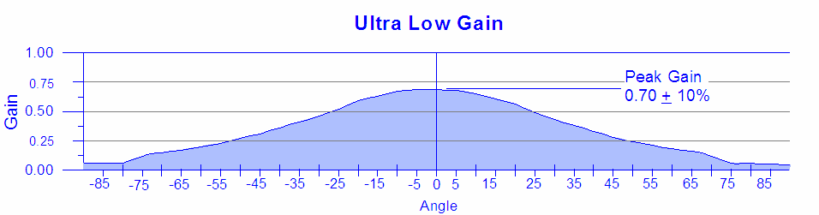

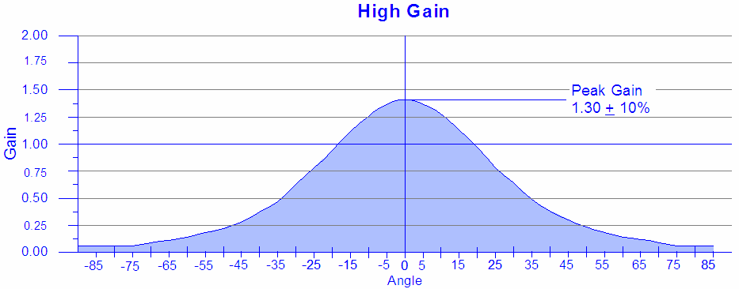
Advantages
- Amazingly deep and bodied optical presentation of the projection
- Truly faithful replication without lens element aberrations, moiré or rainbows
- Extremely uniform & balanced color representation
- Outstanding contrast and sharpness
- Expansive viewing cone horizontally and vertically
- Unrivaled comparative performance in ambient exposure conditions
- Unlimited resolution acceptability without scintillation
- No ghosting (white/bright shadow-bleaching on darker image backgrounds)
- Custom thickness, sizes, and shapes up to 340” diagonal
- Beyond real 3-D stereoscopic projection (spectacular 3-D contrast ratios)
- Diverse range of applications, conditions, and designs
- Self-rigidity for frame-less presentation upright in a stand or free-floating suspension
- Durability and safety during shipping, installation, and client use
- Standard acrylic finish for limited simultaneous projection functionality
- Ease of maintenance & repair. Direct contact with screen with pointers or color markers in presentations. Minor scratches and wear/tear fixable by simple surface re-polishing. No lenses or surface screen elements to be damaged. (as seen in the photo to the right)
- Custom thickness, sizes and shapes for unique applications

Uses
Blue Ocean® is perfectly suitable for home theater, cinema, news rooms, control centers, corporate board rooms, commercial conferences, awards-concert presentations, education facilities, outdoor advertisements, museums, theme parks, sport arenas, pools, simulators, aquariums...the possibilities are simply endless!
Blue Ocean® is so versatile it can even be used in full outdoor weather conditions and for the extreme in hydrostatic large scale pool or aquarium applications.

Blue Ocean® in 150 Words Or Less

Looking for a brief description of Blue Ocean® Projection Screens for your publication? Please select one of the descriptions below that fits your needs.

Blue Ocean® in 125 Words Or Less
Blue Ocean® Screens are the first ever to cast the screen into a hi-tolerance viewing plane centered between two ultra-clear panels of cell-cast acrylic. This construction offers self-rigidity, unrivaled durability, and an amazingly deep and bodied image. The proprietary diffuser Blue Ocean® creates extremely uniform and balanced color representation, outstanding contrast and sharpness, and an expansive viewing cone horizontally and vertically for an image that appears to be flowing out of the screen. Standard sizes are available in 72”, 84” and 100” 16:9 and they can also be custom fabricated into any geometric shape imaginable: curved walls, hemispheres, teardrops, or tunnels. These shapes can come in the world’s largest seamless sizes up to 27’ by 11’. Please visit www.usnippura.com for more information.

Blue Ocean® in 50 Words Or Less
Blue Ocean® Screens are cast into a hi-tolerance viewing plane centered between two ultra-clear panels of cell cast acrylic which offers self-rigidity, unrivaled durability, and an amazingly deep-bodied image. The Blue Ocean® diffuser creates extremely uniform color representation, outstanding contrast and sharpness, and an expansive viewing cone horizontally and vertically.

U.S. Nippura, Inc. | 3611 Tryclan Dr. | Charlotte, NC 28217
T: 704-561-9191 | F: 704-561-9196 | www.usnippura.com

